**FIRST MILESTONE**

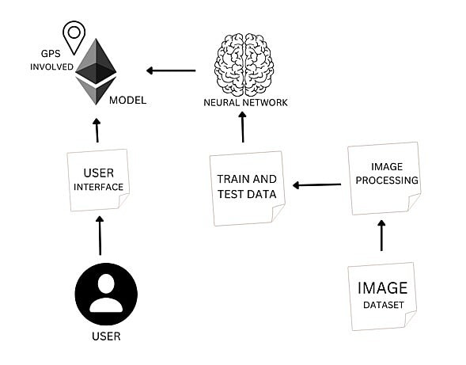

1. This project is based on image processing and voice recognition using Artificial Intelligence.
2. For people with disabilities, mobility proves to be one of the challenging issues to overcome.
3. This ensures safe and secure mobility for the visually impaired.
4. In this project , the global positioning system is involved and this uses satellite technology to provide auditory feedback to the visually impaired regarding their position, direction of movement , environment and routes.